Support True Informed Consent
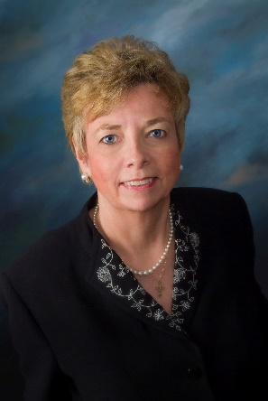
NACN-U.S.A. is a party to an amicus brief in the Arizona case, Planned Parenthood v. Brnovich case which is currently pending before the U.S. District Court for the State of Arizona (15-01022). Planned Parenthood et al are challenging the recent amendment to Arizona’s informed consent law that requires abortion providers to inform women that it may be possible to reverse the effects of a chemical abortion, and that time is of the essence. It also directs the Arizona Department of Health to update the state-prepared informed consent materials to provide information on how a woman can contact a physician to help her.
The provision is informational only—it does not regulate the chemical abortion procedure. It simply ensures that, should the woman regret her decision (after ingesting the first drug, mifepristone, but before the second drug, misoprostol), that she has a way to contact someone who may be able to assist her in reversing the process (through administration of progesterone)—and ensuring that she knows that time is of the essence.
As nurses, we respect the fact that informed consent is a standard of our profession. Health care providers need to ensure that women have all the information they need to make a truly informed decision. Evidence demonstrates that frequently women regret the decision to have an abortion. Timely information on how to reverse any such grave decision is a right of all patients and should not be obstructed. (Rec. 8/20/2015)
The National Association of Catholic Nurses, U.S.A. signed the Amici Curiae with the American Association of Pro-Life Obstetricians & Gynecologists, Physicians for Life, National Association of Pro-Life Nurses in support of the defendants.
Read AMICUS Brief: https://nacn-usa.org/wp-content/uploads/15-01022-amicus-brief-of-AAPLOG-et-al.pdf

From: Dr. Marie Hilliard, PhD, MS, MA, JCL, RN, NACN-USA, Northeast Regional Director and Director of Bioethics and Public Policy for The National Catholic Bioethics Center. She assists the NACN-U.S.A.’s Ethics and Spirituality Committee.

