NACN-U.S.A. Continues to Advocate for Religious Freedom
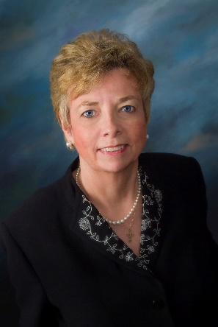
The School of the Ozarks, Inc v. Right Choice Managed Care, Inc.

The NACN-U.S.A. again has been a signatory to an amicus brief in support of the right of organizations, especially faith-based organizations, to the free- exercise of religion guaranteed by both the First Amendment of the United States Constitution, as well as the Religious Freedom Restoration Act of our federal statutes.
The U.S. Court of Appeals for the Eight District is hearing the appeal of Ozark College, a Christian college denied injunctive relief by a lower court and with an order of dismal of their complaint by the United States District Court for the Western District of Missouri Southern Division. Ozark College had sought relief from being mandated to violate its religious freedom by the unjust contraceptive mandate imposed by the U.S. Department of Health and Human Services, implementing some provisions of the Affordable Care Act (HHS Mandate). Ozark College is seeking relief from being forced to provide, through the contract with an insurance provider for which the College pays premiums, abortion inducing drugs and devices to their employees. These egregious attacks on religious liberty continue to escalate, and the NACN-U.S.A. continues to advocate against such unjust mandates. To date the NACN-U.S.A has been a signatory to eight such amicus briefs against the unjust HHS Mandate.
Also signing are Association of American Physicians & Surgeons, American Association of Pro-Life Obstetricians & Gynecologists, Christian Medical Association, Catholic Medical Association, The National Catholic Bioethics Center, Alabama Physicians for Life, National Association of Pro-Life Nurses (Rec. 5/15/2015).
Read Case: https://nacn-usa.org/wp-content/uploads/SchoolOzarksvRightchoice.pdf

From: Dr. Marie Hilliard, PhD, MS, MA, JCL, RN, NACN-USA, Northeast Regional Director and Director of Bioethics and Public Policy for The National Catholic Bioethics Center. She assists the NACN-U.S.A.’s Ethics and Spirituality Committee.

