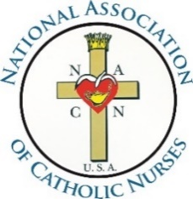
“Unity in Charity”
where NURSING, MINISTRY and CATHOLIC MISSION meet

Dear Potential member of the Board of Directors/Committee Chair,

Thank you for your interest in serving in a leadership role in the National Association of Catholic Nurses-USA (NACN-USA). We recognize that volunteers like you, who commit their time and share their passion for uniting nurses across the United States, are the heart of our organization.

NACN-USA was initially formed following the formation of the International Catholic Committee for Nurses and Medico-Social Assistants (CICIAMS) whose first meeting was held in Lourdes in 1933. In 1938 Pope Pius XI, through his spokesperson, G. Cardinal Pizzardo, encouraged the bishops to organize local associations of Catholic nurses according to the needs of their respective diocese and in time create a National organization. Disbanded for 20 years, there was great interest from the local councils who remained to reestablish the national organization. In 1993 the NACN-USA was formed under the auspices of the Diocese of Joliet, Illinois, with the permission and spiritual advisement of Bishop Joseph L. Imesch. NACN-USA is a full voting member of CICIAMS and in October 1996, NACN-USA was approved by the U.S. Conference of Catholic Bishops for inclusion in the “Official Catholic Directory.”

Consistent with NACN-USA’s mission, the organization gives nurses of different background, but with the same Roman Catholic values, the opportunity to promote 1) Catholic moral principles within nursing, 2) the Christian vocation within the world, and 3) the opportunity for professional development. This approach to Roman Catholic doctrine focuses on educational programs, spiritual nourishment, patient advocacy, and integration of faith and health. As we continue to share our faith and values with each other, and with other healthcare providers, we simultaneously reach outward to the larger Church and also our communities, as we offer support to those in need.

To begin the application process, please fill out this packet in its entirety and return to the catholicnurses@nacn-usa.org. There are four main sections of the application packet:
- Profile Information Sheet
- Commitment to the Mission and Objectives of NACN-USA
- Pastoral Letter of Reference (format included)
- Character Reference (format not included)

Please have your Pastoral Letter of Recommendation, as well as your Character Reference, scanned and emailed to the NACN-USA office at catholicnurses@nacn-usa.org.

For more information, visit our website at www.nacn-usa.org. The bylaws are available online on the Board of Directors page.

Again, we thank you for your interest and look forward to you helping us unite nurses in your parish, diocese and across the nation.

In His Holy Name,
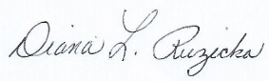
Diana Ruzicka, RN, MSN, MA, MA, CNS-BC
President, National Association of Catholic Nurses-USA

