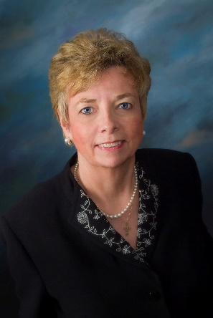
From: Dr. Marie Hilliard, PhD, MS, MA, JCL, RN, NACN-USA, Northeast Regional Director and Director of Bioethics and Public Policy for The National Catholic Bioethics Center. She assists the NACN-U.S.A.’s Ethics and Spirituality Committee.

The National Association of Catholic Nurses-U.S.A. (NACN-USA) continues to support organizations and their rights to religious freedom, being violated by the U.S. Department of Health and Human Services’ Contraceptive Mandate.
The NACN recently joined other organizations committee to the protection of religious freedom in signing on the following Amicus briefs, in support of those employers who are legally challenging the violations of their conscience rights:
- Dordt College and Cornerstone University (UNITED STATES COURT OF APPEALS FOR THE EIGHTH CIRCUIT, DORDT COLLEGE and CORNERSTONE UNIVERSITY, v. SYLVIA M. BURWELL);
- the Archdiocese of St. Louis (UNITED STATES COURT OF APPEALS FOR THE EIGHTH CIRCUIT, ARCHDIOCESE OF ST. LOUIS and CATHOLIC CHARITIES OF ST. LOUIS. v. SYLVIA M. BURWELL);
- East Texas Baptist University and Westminster Theological Seminary (UNITED STATES COURT OF APPEALS FOR THE FIFTH CIRCUIT EAST TEXAS BAPTIST UNIVERSITY; HOUSTON BAPTIST UNIVERSITY, WESTMINSTER THEOLOGICAL SEMINARY, v. SYLVIA MATTHEWS BURWELL).
These briefs represents a total of six amicus briefs filed by the NACN in support of religious freedom being violated by the HHS Contraceptive Mandate.

UPDATE

NACN-U.S.A. Continues to Advocate for Religious Freedom — Dordt College & Cornerstone University
Recent Good News: The CNS International Ministries, Inc., Heartland Christian College,[i] Dordt College and Cornerstone University[ii] were granted favorable opinions in the ruling by the 8th US Circuit Court of Appeals that their religious liberty had been violated by the HHS Contraceptive Mandate.
The National Association of Catholic Nurses-U.S.A. is a signatory to the amicus brief that was before this court in support of Dordt College and Cornerstone University. [Read Appellate Case] (Rec. 9/18/2015).

