Congratulations!
The 2024 NACN-USA Bylaws were overwhelmingly approved.

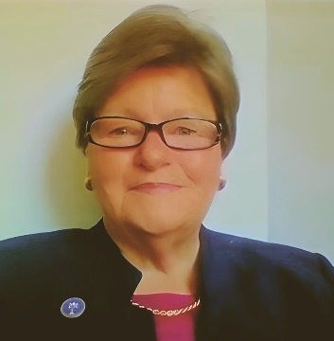

With the approved 2024 Bylaws, NACN-USA can better facilitate opportunities for:
• Parish-based, School-based, and Healthcare Agency-based Councils
• Member engagement and leadership
• CEU webinars starting the 2024-2025 Academic Year
• And more ...
“Moving Forward”
Please frequently check the NACN-USA Website over the next 90 days. Initiatives with leading
Catholic Universities, College Schools of Nursing, and Catholic Healthcare Systems are about to be actualized. In addition, a schedule of “Watch Party” videos will be announced to begin this fall.
Volunteers are always welcome and sought.

Thank you for your vote.

Sincerely,
Patricia Sayers
Dr. Patricia Sayers, DNP, RN
President, National Association of Catholic Nurses, USA

