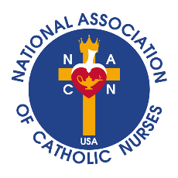

Unity in Charity

*where NURSING, MINISTRY and CATHOLIC MISSION meet*

April 26, 2025

Dear National Association of Catholic Nurses, USA Members,

We mourn the death of our Pontiff, Pope Francis, and pray for the repose of his soul. Let us thank God for Pope Francis’ love and support of all nurses, physicians, and healthcare workers around the world. During his pontificate, Pope Francis especially loved the poor and marginalized, the sick and the frail, and he loved and thanked all nurses who care for them.

Pope Francis reminded us that caring for the sick is a gift, and he asked us to unite the sufferings we experience in our daily work with the suffering of our patients. Thereby, growing together in hope on our journey toward holiness, we are united in Christ’s sufferings, yet hoping in His resurrection. May we always recall Pope Francis’ exhortation to live as believers, to allow the Holy Spirit to illuminate our lives, and the lives of our patients with the light of hope!

Let us continue to pray for the repose of the soul of Pope Francis during these 50 days of Eastertide. Let us pray to our fellow nurse, Saint Catherine of Siena, to intercede for our Holy Catholic Church, so the College of Cardinals will listen to and heed the voice of the Holy Spirit in electing our new pope.

God Bless you and your families.

Sincerely,

**Bonnie Blachly MN, BSN, CEOLD**

Bonnie Blachly, MN, BSN, CEOLD

President, National Association of Catholic Nurses, USA

NACN-USA.org