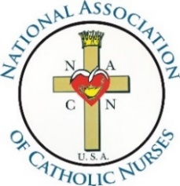
Unity in Charity
where NURSING, MINISTRY and CATHOLIC MISSION meet

Part 2: Commitment to Mission and Objectives
according to the NACN-USA bylaws

I, __________________________________, in assuming my leadership role of ______________________________ on the Board of Directors or as a Committee Chair of the National Association of Catholic Nurses-USA (NACN-USA), firmly support the mission of NACN-USA to:
Give nurses of different backgrounds, but with the same Roman Catholic values, the opportunity to promote moral principles within the Catholic context in nursing and stimulate desire for professional development. This approach to Roman Catholic doctrine focuses on educational programs, spiritual nourishment, patient advocacy, and integration of faith and health. As we continue to share our faith and values with each other, and with other healthcare providers, we simultaneously reach outward to the larger Church and also our communities, as we offer support to those in need (Article I)

I commit to supporting the NACN-USA objectives to:
1. Promote education in Catholic nursing ethics;
2. Nurture spiritual growth;
3. Provide guidance, support, and networking for Catholic nurses and nursing students, as
well as other healthcare professionals and non-healthcare professionals who support the
mission and objectives of the NACN-USA
4. Advocate for those in need through efforts which integrate faith and health (Article IV).

I accept Roman Catholic values and moral principles within the context of nursing. (Article VI, Section 2, B1).

I will assure that my actions on behalf of the association and in my personal life maintain fidelity to the teachings of the Roman Catholic Church and the directives of the Holy Pontiff (Article X, Section 3, C3)

Member’s Name: Email:
Member’s Address:
City, State, Zip Code:
Phone Number:_____________________________ *Payment Transaction #:
*Dues Invoice Number: *Dues Invoice Date:
(*Completed by NACN-USA Treasurer)

__________________________________ __________________________ Member’s Signature Date

