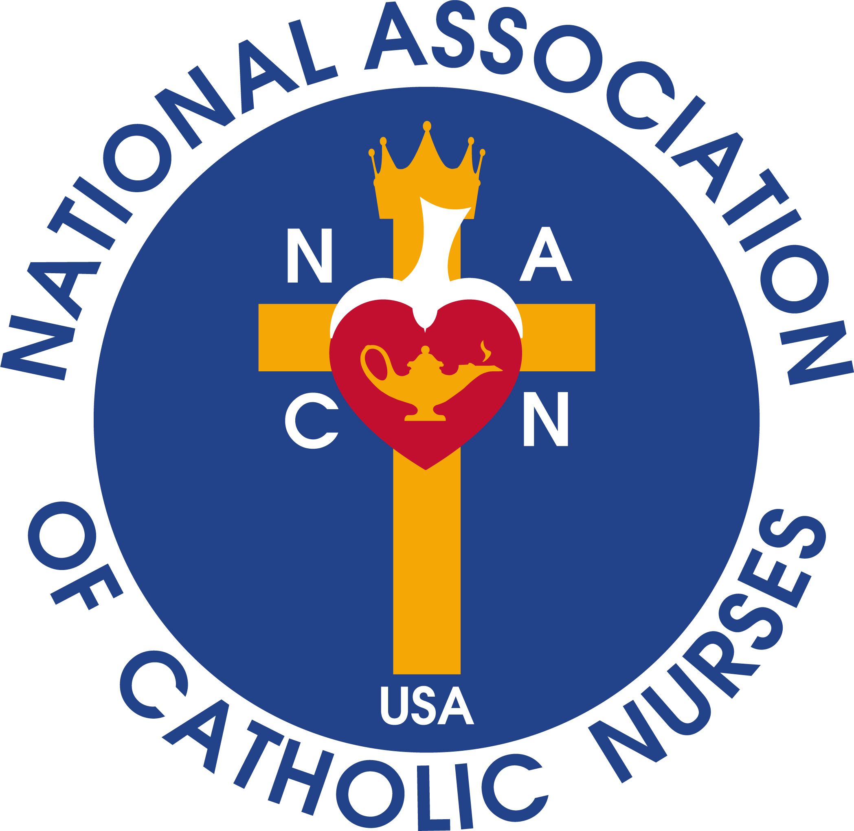
National Association of Catholic Nurses, U.S.A.
where NURSING, MINISTRY and CATHOLIC MISSION meet
“Unity in Charity”
Spiritual Resources
during times of Social Distancing

An Act of Spiritual Communion, written by St. Alphonsus of Liguori:
My Jesus
I believe that You are present in the Blessed Sacrament.
I love You above all things and I desire You in my soul.
Since I cannot now receive You sacramentally,
come at least spiritually into my heart.
As though You were already there, I embrace You and unit myself to You; permit not that I should ever be separated from You.
Amen

O Sacrament Most Holy, O Sacrament Divine,
All Praise and All Thanksgiving be every moment Thine.
Holy Sacrifice of the Mass
- Diocese & Parishes – Many Bishops and Priests are making their offering of the Holy Sacrifice of the Mass available via live streaming, Facebook and other electronic media.
- The Holy Father, Pope Francis is live streaming daily mass from Rome at noon, 7am EST
- EWTN.com will broadcast Mass on TV at 8am, noon, 7pm EST and EWTN Radio Essentials will air the Holy Sacrifice of the Mass every 2 hours from 8am to midnight EST.
- Word on Fire (Bishop Robert Barron)
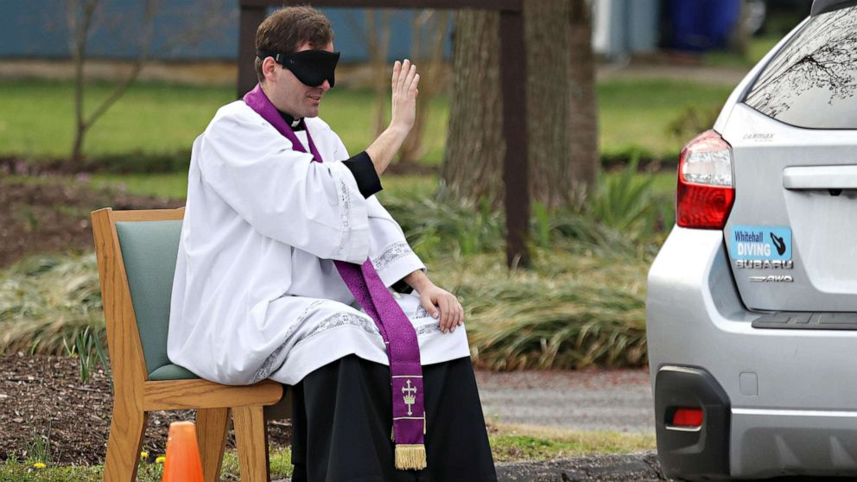
Sacrament of Reconciliation
- Diocese and Parishes – Several are offering the sacrament of reconciliation as long as parishioners maintain the specified 6 foot distance between those in line. Others are offering the sacrament from your car. Please check with your local parish so that you may receive this important sacrament, especially during the Lenten Season.

Stations of the Cross – Meditation on the Passion of Jesus (3pm) daily, recommended by Jesus
- YouTube – search “Stations of the Cross – There are many options
- The Way of the Cross with St. Alphonsus De Liguori (read online)
- The Way of the Cross with St. Faustina Kowalska (read online)
- Stations of the Cross according to St. Francis (audio)
- Stations of the Cross from the Via Dolorosa in Jerusalem with Catholic Online (audio & visual)
To St. Faustina (1905-1938) - Meditation on the passion of Jesus is an essential element of devotion to The Divine Mercy. In her Diary entry #369, St. Faustina records that Jesus said, "There is more merit to one hour of meditation on My sorrowful Passion than there is to a whole year of flagellation that draws blood; the contemplation of My painful wounds is of great profit to you, and it brings Me great joy." Jesus encouraged St. Faustina to make the Stations of the Cross as a way of immersing herself in His Passion and invoking His mercy for the whole world. “I remind you, My daughter, that as often as you hear the clock strike the third hour, immerse yourself completely in My mercy, adoring and glorifying it; invoke its omnipotence for the whole world, and particularly for poor sinners; for at that moment mercy was opened wide for every soul. In this hour you can obtain everything for yourself and for others for the asking; it was the hour of grace for the whole world — mercy triumphed over justice.” and ‘My daughter, try your best to make the Stations of the Cross in this hour, provided that your duties permit it” (1572).

Prayers
Eucharistic Adoration
- Diocese & Parishes – in some diocese, parishes are open for private prayer and Adoration of Jesus in the Blessed Sacrament.
- EWTN - Eucharistic Adoration, 9am to 6pm online at https://www.ewtn.com/catholicism/adoration
- Shrine of the Most Blessed Sacrament in Hanceville, Alabama’s main Church is open for Eucharistic Adoration each day from 8:00 AM to 4:00 PM
Note. PLEASE remember to honor all instructions and requests regarding the number of people in a room or area at the same time and to maintain a 6 foot distance from others. For instance, in Alabama: (Please check your diocesan website)

Novenas – Pray More Novenas offers novenas throughout the year.
Prayers, Liturgical Calendar, Mass Readings, Full text classic Catholic Books - iPieta
Liturgy of the Hours – DivineOffice.Org or iBreviary
Free Access to Magnificat daily readings and prayers

Other Resources
- The Augustine Institute is now offering free 40-day subscriptions to the Formed online Catholic library. There are movies, courses, mass, prayers, items suitable for all ages, both English and Spanish language. If your parish doesn’t have a Formed subscription or you haven’t looked up your subscription code, you can sign up for free at www.formed.org/faithathome
- Visit the Vatican Museums – 7 virtual tours online

Regional Director/Local Council Prayer Meetings Online– Maria Arvonio, LNE Regional Director held an online meeting with Catholic Nurses in her region March 31, 2020. You can too… Here are some steps for meeting online:
1. Say a prayer for your group and for yourself. Saint Isidore of Seville (560-636) is the patron saint of computer technicians, computer users, computers, the Internet, schoolchildren and students.
2. Online programs available are: Webex, Google Hangouts, Skype, and Zoom
3. Set up the meeting time and date
4. Provide time, date, link and any password to Chair, Communications Committee, JanetMunday@gmail.com giving her plenty of notice to have her committee send a MailChimp message to nurses in your region.
5. Host the online forum, meeting, prayer group.
6. If you have a list of email addresses, you may invite nurses directly through one of the above online programs.
7. May God bless each one of you as you unite and support each other across the nation.

3/27/2020-DLR

